

April 9th, 2020

**MSE 222**

Kinematics and Dynamics of Rigid Bodies and Mechanisms

Instructor: Dr. Carolyn Sparrey

**Project Report**

Design and Simulation of a Dynamic System

Matthew Ariho (301374078)

Prabnoor Singh (301363620)

Aryan Archan (301360397)

Kedar Kattimani (301355386)

Table of Contents

1.Introduction **2**

2. Methods and Results of Simulation **3**

3.Sensitivity study **7**

4.Environmental Impact Assessment **8**

5.Conclusion **8**

6.Bibliography **9**

7.Appendix **9**

## 

## 1.Introduction

The main objectives of this project and subsequently, all the components involved leading up to the report are to gain a better understanding and appreciation of the fundamental concepts the kinematics and dynamics of not just a single rigid body but how it interacts with the system built around it. In this project, we specifically worked with a system that constituted components such as ramps, curved paths, a compressed spring, a rotating element and impacts that when combined planarly accelerated our rigid body(marble ball) both linearly and angularly in order to move the ball from the top of the vertical slab to the bottom in a target time of 20 seconds. An additional stipulation that we had to keep in mind while working on the project was when it came to physically building the system, the raw materials used should be acquired in environmentally friendly means and disposed of as such. We expected this project to improve our understanding of how the building blocks of any system are chosen and designed to work in harmonic union with each other. Otherwise, the system would not work. And our conclusions on this would be necessary/make sense/useful in a multitude of applications involving complex mechanical or even electrical systems.

Our first hurdle we had to navigate in the project came early on during the design process, given the multiple constraints and design requirements dictated in the project manual. In essence, we had to build a system that involved different components and the different scenarios that complemented each other in getting the ball from point A to B. We also had to ensure that the design was somewhat unique in its conception. To remedy this, we decided to implement our creative freedom in what the rotating element, the impacts and the loading system would be. For the loading system, the decision to settle for a compressed spring instead of a pendulum was mainly influenced by environmental impact concerns. Springs are easily accessible and plug-and-play while a system involving a pendulum would have to be built from scratch, which would logically/truthfully/sensibly be done iteratively to fabricate it sufficiently for our application which would accumulate a significant amount of waste. As for the components responsible for the rotating and the impact mechanisms of our system, we decided to move forward with a fabricated gear and gates. These combined with our ideas for what the rest of the track, a preliminary version (without any real dimensions in mind) was born:

As evidenced from the figures 1 and 2(in the appendix) of our system design in different stages, our system has 11 sub-systems/regions through which the ball travels through to reach its final destination. Each region was analyzed to produce a comprehensive simulation of our system, using a combination of the equations of motion, kinematic equations, force analysis equations, conservation of energy equations and momentum equations and reproduced in MATLAB. It is important to note that some of these analyses take some leisure in terms of accuracy as some assumptions had to be made to lower the complexity when writing the code required to replicate the analysis in MATLAB. One of the more overlapping assumptions made was that the ball is never slipping while rolling and that given the larger force incident on the ball at the beginning of its motion, the forces due friction were negligible. That aside, the analyses were done separately and independently for each component type and orientation in MATLAB function files, but we wrote in such a way that they could be used in sequence with each other to simulate the entire track. A more comprehensive look at the analyses used for each component is given a section below.

## 

## 2. Methods and Results of Simulation

The isometric view of our ball track is shown in Figure 1. This model was built on Solidworks software. All lengths and angles of ramp are shown in Figure 2. All lengths are in centimeters and corresponding angles are in degrees. These values were used in our MATLAB simulation. Figure 3 includes the height at which the ball drops throughout its journey on the track along with the front view of the model.

**Region 1**: The ball’s motion starts with a spring A spring gives the ball a preset 1 N of force which causes the ball roll, starting its motion. To find both the linear and angular velocity of the ball after the impact with the spring, we assume that within this system, energy is conserved so the sum of kinetic and (elastic) potential energies before and after the impact are equal. Given that the elastic potential energy of a spring is given by;

$V=\frac{1}{2}kx^{2}, where k=Hooke^{'}s spring stiffness constant$

$and x=displacement from the equilibrium position due to compression$

and the kinetic energy (due to both rotation and translation since it’s rolling) of the ball’s center of gravity is given by;

$T=\frac{1}{2}m_{b}v_{x}^{2}+\frac{1}{2}I_{G}ω_{b}^{2}, where I_{G} is the moment of inertia about the ball^{'}s centroid$

According to conservation of energy, we have:

$T_{1}+V_{1}=T_{2}+V_{2} where T_{2} as the spring has no extension after impact$

$and V_{1}=0 because the ball starts from rest$

Given the no slip assumption as the ball rolls, we obtain a relationship between the angular and linear velocities of the ball, $v_{x}=r∙ω_{b}$ which makes our equation simplifies to;

$\frac{1}{2}kx^{2}+0=\frac{1}{2}m_{b}(ω_{b}{r)}^{2}+\frac{1}{2}I_{G}ω_{b}^{2}+0=\frac{1}{2}ω_{b}^{2}\left(m_{b}r^{2}+I_{G}\right)$

Since the ball is spherical, the moment of inertia about its center of gravity is $I_{G}=\frac{2}{5}m_{b}r^{2}.$ Substituting this back in our equation and making $ω_{b}$ the subject of the equation;

$\frac{1}{2}kx^{2}=\frac{1}{2}ω_{b}^{2}\left({\frac{7}{5}m}_{b}r^{2}\right)→ω_{b}^{2}=\frac{5kx^{2}}{{7m}_{b}r^{2}}→ω_{b}=\frac{x}{r}\left(\sqrt{\frac{5k}{{7m}_{b}}}\right)$

And to find the force on the ball due to the spring, we used the following momentum equation;

$mv_{1}+ \int_{0}^{t}{}F_{x}dt=mv_{2}$

where t is the time of the impact, v1 is the initial velocity and v2 is the velocity of the ball after the impact. Since Fx is dependent of time and v2 = vx, this equation simplifies to $F_{x}∙t=mv_{2}=\frac{mx}{r}\left(\sqrt{\frac{5k}{{7m}_{b}}}\right)$. We assumed that the time of impact was approximately 1.5 milliseconds.

**Region 2**: After the ball is provided with the initial spring force, it rolls onto the flat track. Given our negligible friction assumption, the linear and angular velocities remain constant through this region.

**Regions 3, 5, 8 and 10**: In this section, the ball rolls along a ramp all the way to the end, being the bounding wall.  For region 3, we designed it in a way such that it impacts the wall, comes to stand-still then falls through the hole beneath it, accelerating downwards due to gravity until it reaches the next region. For the first part of this region, we had to determine the linear acceleration of the ball using the equations of motion as shown below;

|  |
| --- |
| $\sum{}F_{x}=ma_{x}=-Nsin⁡(θ)$ |
| $\sum{}F_{y}=ma_{y}=Ncoscos \left(θ\right) -mg where N is the normal force$ |
| $\sum{}M_{A}=\left(I_{G}+mr^{2}\right)α=mgrsin(θ) where A is the instantenous center of zero velocity$ |

the positive direction of the x, y and moment are to the right, upwards and counter-clockwise respectively. Using the kinematic equations, we find the components of linear acceleration as;

|  |
| --- |
| $a_{x}=-ω_{0}^{2}rsin\left(θ\right)+αrcos\left(θ\right)$ |
| $a_{y}=ω_{0}^{2}rcos\left(θ\right)+αrsin\left(θ\right) where ω_{0 }is the initial ang. velocity$ |

The position and velocity of the ball at time(t) is calculated as;

|  |
| --- |
| $x=x_{o}+{(ω}_{0}rt+\frac{1}{2}αrt^{2})cos\left(θ\right)$ $V_{x}=-ω(t)rcos(θ$) |
| $y=y_{o}-(ω_{0}rt+\frac{1}{2}αrt^{2})sin\left(θ\right)$ |

$V_{y}=-ω\left(t\right)rsin\left(θ\right) where ω\left(t\right)= ω_{0}+αt$

Note: these are sample calculations made using Region 3 in mind. Adjustments would have to be made for the other regions. Adjustments like how the x-position is calculated.

**Region 4, 7 and 9**:  The ball falls into a curved path that is modelled by a semicircle of specified radius. This motion is mainly dictated by the change in potential energy due to changes in height as the ball traverses the curve. We assume no losses in energy so for every change in $θ$ (measured from the top of curve), we find the time elapsed by;

$T_{1}+V_{1}=T_{2}+V_{2}→\frac{1}{2}m_{b}v_{x1}^{2}+\frac{1}{2}I_{G}ω_{b1}^{2}+mg∆h= \frac{1}{2}m_{b}v_{x2}^{2}+\frac{1}{2}I_{G}ω_{b2}^{2}$

Since, $∆h=rsin\left(θ\right),v_{x2}=R∙ω_{b2}$ where R is the radius of the curve and $ω_{b}=\frac{dθ}{dt}$, we can rewrite this entire equation with $\frac{dθ}{dt}$ as the subject, find its reciprocal then integrate both sides by $dθ$ w with $θ_{1}$ and $θ_{2}$ as bounds to find the time elapsed.

$∆t= \int_{θ_{1}}^{θ_{2}}{}\sqrt{\frac{m_{b}r^{2}+I_{G}}{ m_{b}v_{x1}^{2}+I_{G}ω_{b1}^{2} + 2m_{b}grsinsin θ } } dθ$

Given the position (in terms of $θ$) at a time(t), we can calculate the angular and linear accelerations using our equations of motion in the tangential and normal direction.

$\sum{}F_{t}=ma_{G}=mαr ;given the no slip assumption$

This gives;

$α=-\frac{mgrcos(θ)}{I_{G}+mr^{2}}$

And using the kinematic equations, we obtain the linear acceleration components as;

$a_{x}= -αrcos\left(θ\right)+ {ω_{0}}^{2}rsin\left(θ\right)$

$a_{y}= -αrsin\left(θ\right)- {ω_{0}}^{2}rcos\left(θ\right)$

The normal force at each position can be calculated as;

$N= -m{ω_{0}}^{2}R+mgcos(θ)$

The centripetal force acting on the ball at all positions in these regions is defined by;

$F= m{ω_{0}}^{2}R$

Note: these are sample calculations made using Region 4 in mind. Adjustments would have to be made for the other regions based off the direction of the curve. Adjustments like how the x-position is calculated.

**Region 6**:  In this region, the ball’s motion is dictated by the moment of inertia of the rotating element which bears some resemblance to a gear. In essence, the ball impacts one of the teeth of our makeshift gear, as such, the gear starts rotating about its center of mass. The initial assumption for the kinematic scene in this region was kinetic energy was conserved. However, we decided that this would not be a reasonable assumption so we decided to account for the energy loss of the impact using the concept of restitution. However, the coefficient of restitution would be governed by the material used to fabricate the gear and the choice of this material was limited due to environmental concerns. As discussed in the environmental discussions, we settled for cork. Given cork’s highly absorbent nature, we deliberated and decided than a coefficient of restitution of 0.4 would be highly appropriate. With this in mind, the motion of the ball in this region is modelled by;

$e= \sqrt{\frac{T_{2}(KE after collision)}{T_{1}(KE before collision)}}$

$T_{1}=\frac{1}{2}m_{b}v_{x}^{2}+\frac{1}{2}I_{G}ω_{b}^{2}$

$T_{2}=\frac{1}{2}Iω_{b+g}^{2}$

where I is the moment of inertia of the ball and gear about the center of gravity of the gear and $ω_{b+g}$ is the resultant angular velocity of the ball and gear. Making $ω_{b+g}$ the subject of the equation, we get;

$ω_{b+g}= e^{2}\sqrt{\frac{m_{b}v_{x}^{2}+I_{G}ω_{b}^{2}}{I}}≡e^{2}\sqrt{\frac{T_{1}(KE before collision)}{I}}$

Given the similarities between this motion and curved paths such as regions 4,7 and 9, similar calculations were done to calculate the components of linear velocity and position as the ball made its motions through this region.

It is also important to note that there is one additional “component” that is included in the more linear regions of our system. We implemented a series of gates that acted as our repeated impact requirements for the project. We planned that the gates would be built around a specific coefficient of restitution in mind. This would be done by, for example, increasing the thickness of the walls of the gate. Through a series of simulations, we determined that the most favourable coefficient of restitution between the ball and the gate would be 0.1. This implies that every time the ball impacts a gate with an initial velocity, v0, it emerges from the gates with a tenth of initial velocity (0.1v0).

These are the 10 dimensioned regions of the modelled design and function files that modelled and analyzed each region, taking a matrix of vectors, each storing kinematic data (position, velocity, acceleration, force) as input and outputting an updated matrix with data calculated for a calibrated region. All the necessary computations and graphing were hosted in our MSE_222_main.m script file that worked with the data for the entire system. All regions were inspected and analyzed in MATLAB. With all component function files working as expected, we simulated our system and returned graphs of position, velocity, acceleration and force (as shown in the Appendix of this report) and a completion time of 16.024 s. However, we do believe that if we built the physical system, the discrepancy between the simulated and physical completion times would be minor(less than 15%) and it could be attributed mainly to some of the assumptions (e.g. negligible friction or when our no-slip condition fails) that we made, as well as the inaccuracy in building the system given that the degree of precision and accuracy required for some our dimensions might be unattainable. To support these claims, we run a sensitivity study to investigate the degree/impact effects of minor changes (+/- 10%) in important variables in our simulated system.

## 3.Sensitivity study

Tables 1 and 2 summarise the effects of adjusting the some of the most relevant variables in the system

|  |  |  |  |  |  |  |
| --- | --- | --- | --- | --- | --- | --- |
| Variable | -10% | -8% | -6% | -4% | -2% | 0% |
| Mass of the ball(m) | 16.762 | 16.612 | 16.473 | 16.33 | 16.201 | 16.0264 |
| Hooke’s spring constant(k) | 16.0634 | 16.0574 | 16.0524 | 16.0373 | 16.0314 | 16.0264 |
| Square of coefficient of restitution(e2) | 17.8151 | 17.4243 | 17.0519 | 16.6998 | 16.3522 | 16.0264 |
| Initial compressed length of spring(xs) | 16.0994 | 16.0894 | 16.0689 | 16.0574 | 16.0373 | 16.0264 |
| Density of gear material ($ρ$) | 15.3372 | 15.4779 | 15.6172 | 15.755 | 15.8913 | 16.0264 |

|  |  |  |  |  |  |  |
| --- | --- | --- | --- | --- | --- | --- |
| Variable | 0% | 2% | 4% | 6% | 8% | 10% |
| Mass of the ball(m) | 16.0264 | 15.94 | 15.82 | 15.6992 | 15.59 | 15.4741 |
| Hooke’s spring constant(k) | 16.0264 | 16.0213 | 16.0104 | 16.0054 | 15.9994 | 15.9934 |
| Square of coefficient of restitution(e2) | 16.0264 | 15.7125 | 15.4098 | 15.1128 | 14.8309 | 14.5584 |
| Initial compressed length of spring(xs) | 16.0264 | 16.0213 | 16.0104 | 16.005 | 15.9994 | 15.9934 |
| Density of gear material ($ρ$) | 16.0264 | 16.1601 | 16.2925 | 16.4237 | 16.5536 | 16.6824 |

We collected these values by varying the variables in question by 2% in either direction until the 10% mark was hit. We run the simulations with these changes implemented and collected the completion times for each adjustment in the variable. The simulation was run a total of 55 times to gather all this data. From this data, we learned that the mean completion time was 16.052s with a standard deviation of 0.536s, which is not a significant departure from our nominal value. Graph 5 in the appendix shows the distribution of our simulated completion times. We also found that our maximum deviation from the mean value was 1.7887s which occurred when the square of the coefficient of restitution is decreased by 10%. Similar values were also observed when it was decreased by 8% and increased by 10%. This led us to believe the most sensitive variable was the square of the coefficient of restitution, given that it consistently agitated our system if the deviation from the supposed value was large enough. If we were to build the physical system, we would have to account for this rigorous user testing and precise construction of certain components to ensure the system always operates as planned.

This shows that our system is well-conditioned and not prone to extreme changes or failure when faced with discrepancies with what was expected.

## 4.Environmental Impact Assessment

All of the ramps and the outer shell was supposed to be made from cardboard that came from someone’s workplace (painting store stock comes in medium size boxes, approximately 3-4 weeks of prior usage). The cardboard can be disposed of into recycling afterward, where half of it gets recycled into new cardboard. The other half gets downgraded into paper products [5] It would have been joined by glue.

The rotating device was supposed to be carved from cork using a knife. It would have come from anywhere from 1 year to 8 years of prior use. We would have cut a piece off one of our group member’s old construction projects. We would carve it so the ball can fit while restricting movement so as to avoid it leaving the gear before it has been rotated the full 90 degrees. It would have gone into recycling where it could have been used as a part of another architectural model.

The initial launching mechanism was supposed to be made from a small metal spring. It would have come from a used pen with anywhere between a month to a year of prior use. It would go into recycling where the metal would be recycled into anything metal.

The collecting element was supposed to be a small soda can. It would have come from a soda factory with around 1-4 months of storing soda, and it would go into recycling where it gets decomposed into the aluminum to be used to make other aluminum products (maybe even back to another soda can).

## 5.Conclusion

In this project, we sought out to gain a better understanding and appreciation of dynamics systems involving rigid bodies and setting up systems to achieve some desired effect. We also aimed to make use of knowledge about the different kinematic scenarios we would come across to find a reasonable way to simulate the system being built. The project was set up in such a way that we could make conclusive decisions about the different stages of the system and how they influenced each other. This bulk of this analysis was done using MATLAB. This analysis was by far the most challenging aspect of the project because it required us to have a comprehensive understanding of the kinematic and dynamic systems that we were modelling for the parts of the simulation to work as desired. Through the development process, we observed how systems change and develop into a final product as a project matures because of things that only come to light when an iteration or prototype of the system has been erected. It also taught us to approach problems in more unconventional and unique ways. This was especially evident when we kept referring to the environmental impact assessment when making modifications to our system. This is because engineers should also be aware of the effect they have on the environment, and they should be conscious of it throughout the development process. In essence, this project gave us the most in-depth look at what it is to be an engineer.

## 6.Bibliography

[5] “How to Recycle Cardboard,” Earth911.com. [Online]. Available: https://earth911.com/recycling-guide/how-to-recycle-cardboard/. [Accessed: 29-Mar-2020].

## 7.Appendix

Isometric view of our Ball Track


Figure 1- Isometric view of our ball track

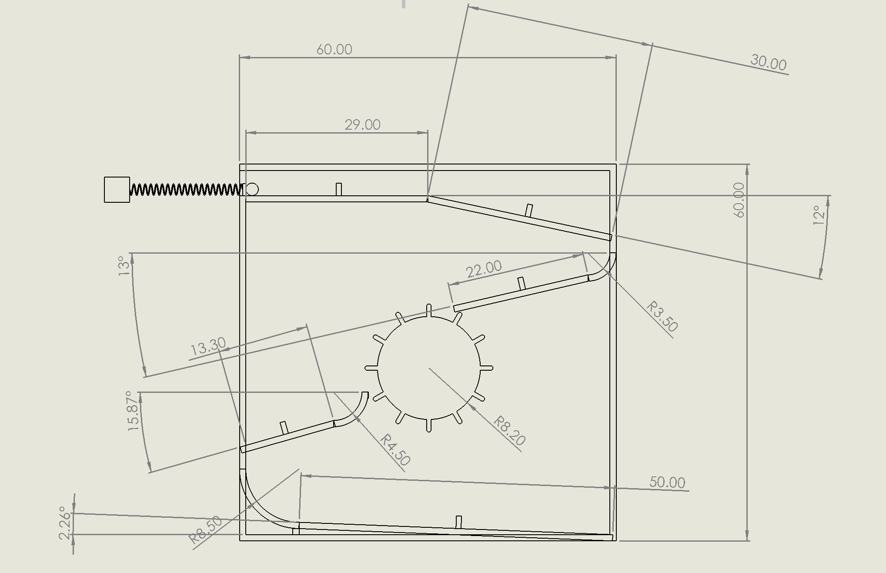

Figure 2 - Dimensions of the model.

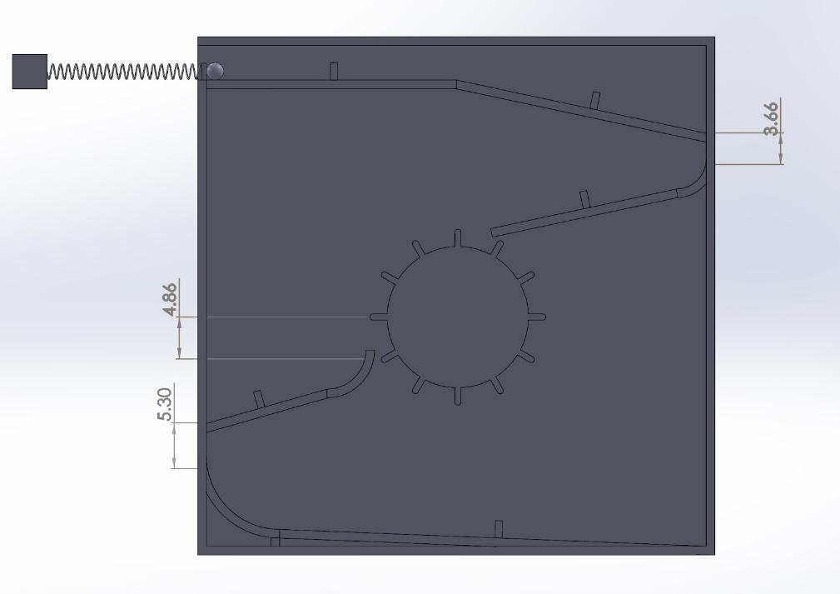

Figure 3 - Height of Ball’s drop throughout the track.

Graph 1 shows the position of the center of gravity of the ball as it goes down the track (y-pos v x-pos)

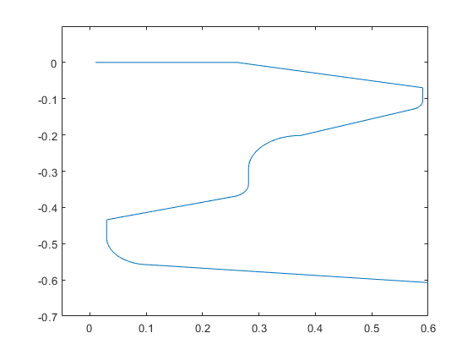

Graph 2 shows the velocity of the ball in the horizontal direction versus time

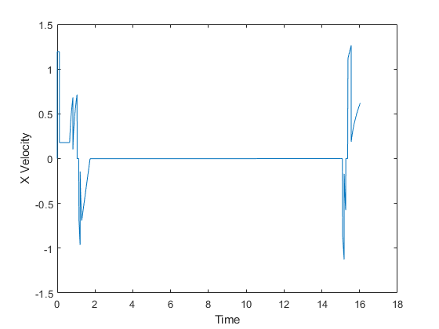

Graph 3 shows the velocity of the ball in the vertical direction versus time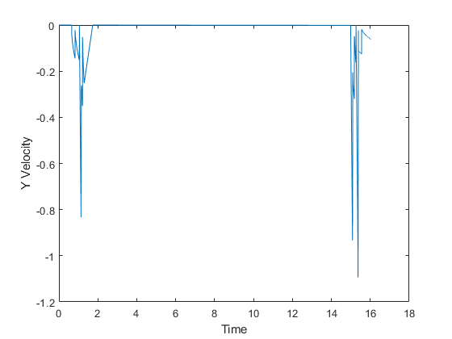

Graph 4 shows the acceleration of the ball in the horizontal direction versus time

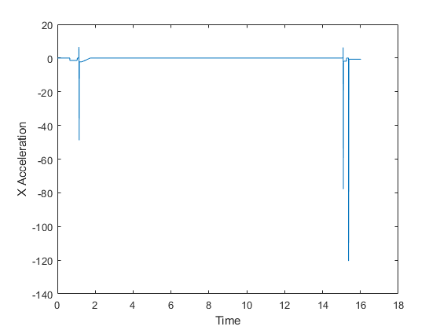

Graph 5 shows the distribution of the data collected in the sensitivity study

